**TSN2101**

**Operating System**

*Trimester 1, Session 2020/2021*

ASSIGNMENT TOPIC: TOPIC 1 – Simulation of CPU Scheduling Algorithms

**(Lecture Section: TC04)**

BY

|  |  |  |  |  |
| --- | --- | --- | --- | --- |
| **No** |  | | **Student ID Student Name** | |
|  | | 1171200748 | | Lee Wang Lin |
|  | | 1171201466 | | Cheok Jia Heng |

Contents

UI PRINT SCREEN 2

# UI PRINT SCREEN

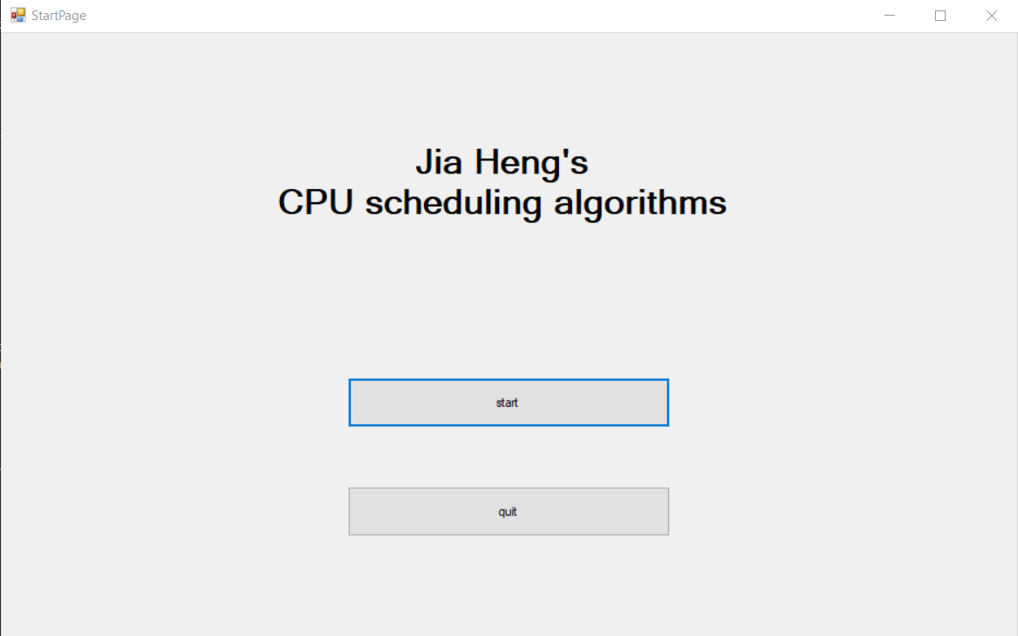

***Figure 1.*** *Start Page*

Figure 1 is the Starting Page where user can could choose to start the program by clicking the start button or quit the program if the user does not want to continue with the program.

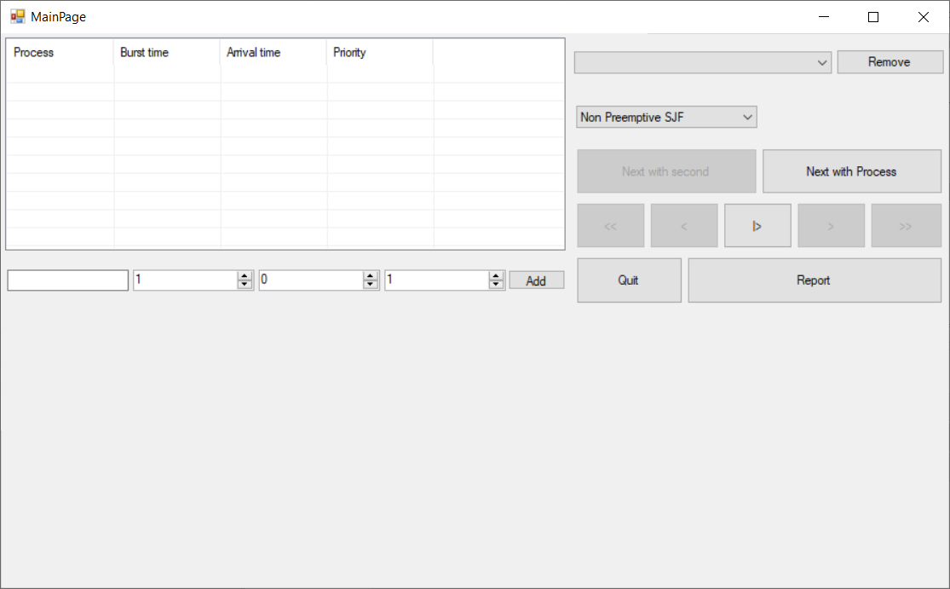

***Figure 2.*** *Main Menu Page*

Figure 2 is the main menu page where the user would be inputting values and choosing the input methods. In this figure, the input method is selected as Non Preemptive SJF. Quit button is used to return to Start Page if user does not want to continue with program.

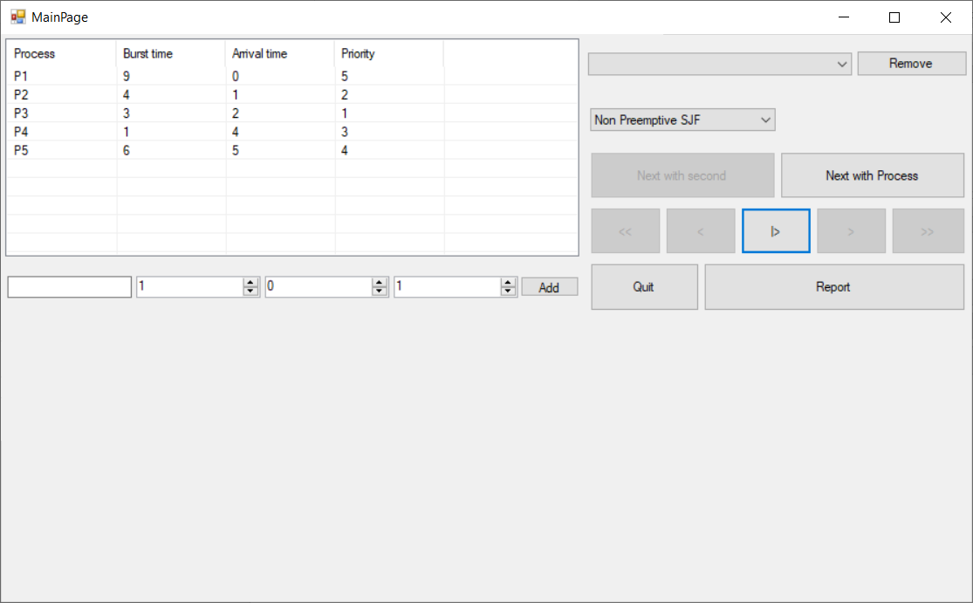

***Figure 3.*** *Adding Process*

In Figure 3 shows adding of process with the Process name, burst time, arrival time and Priority. After input the values in the column and clicking “Add” button, the process value would be inserted into the algorithm previously selected (Non Preemptive SJF in this case).

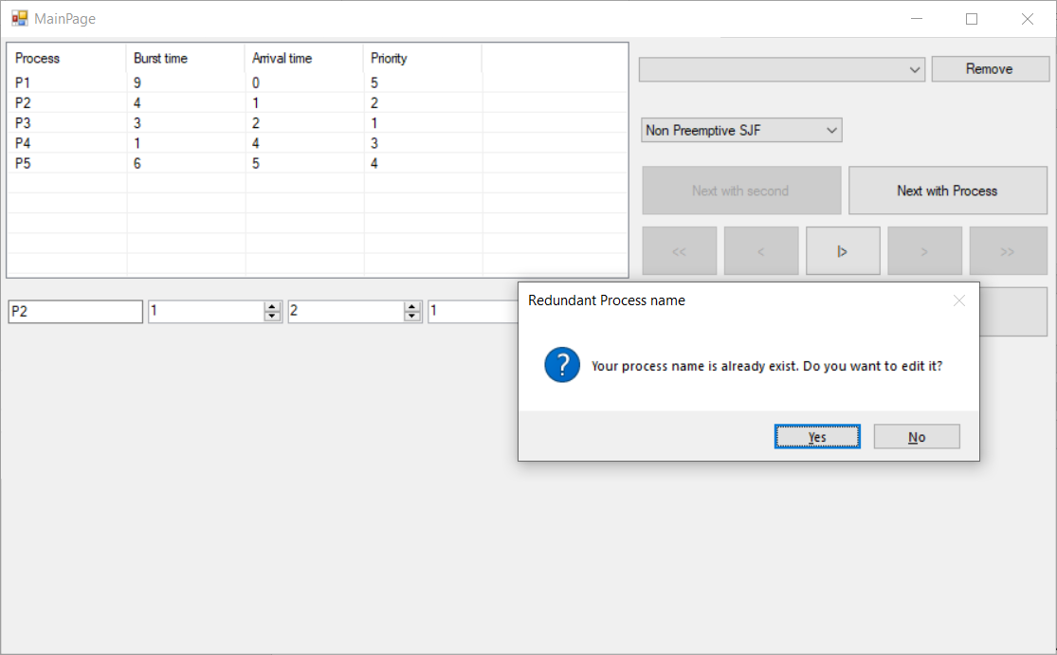

***Figure 4.*** *Edit Process*

In Figure 4 shows the edit screen when the process name is repeated, if the yes button is clicked, the new data with the same process name will be over written over the initial process. When the process name is clicked at the table at the top, the value of the selected process would be prompt in the blank space below for editing.

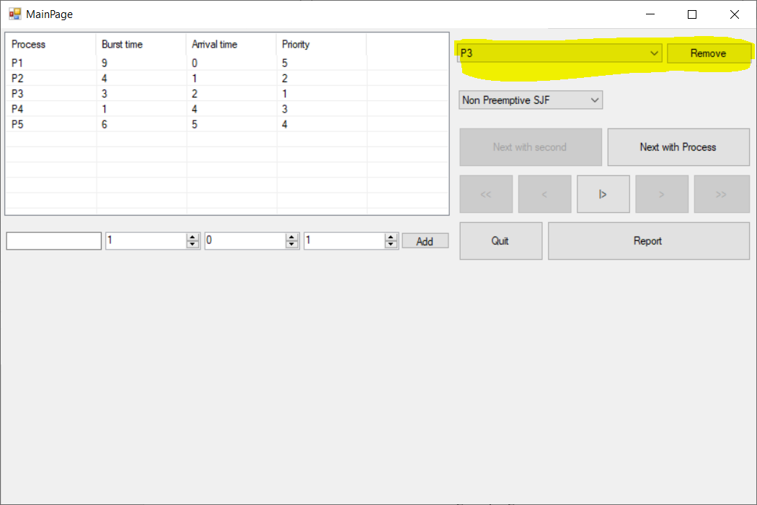

***Figure 5.*** *Delete Process Entered*

In Figure 5, the highlighted part is used to select the process to be removed. If the user entered the wrong data, the user is able to remove the values from the algorithm and re-enter the values without restarting the program.

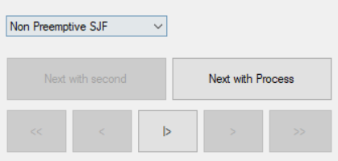

***Figure 6.*** *Select methods presented*

In Figure 6 shows the controller for the starting process and the methods that the data is presented, either presented seconds by seconds by clicking the next button, or process by process. There is option for skipping the process to the first or final state by clicking the double arrow button.

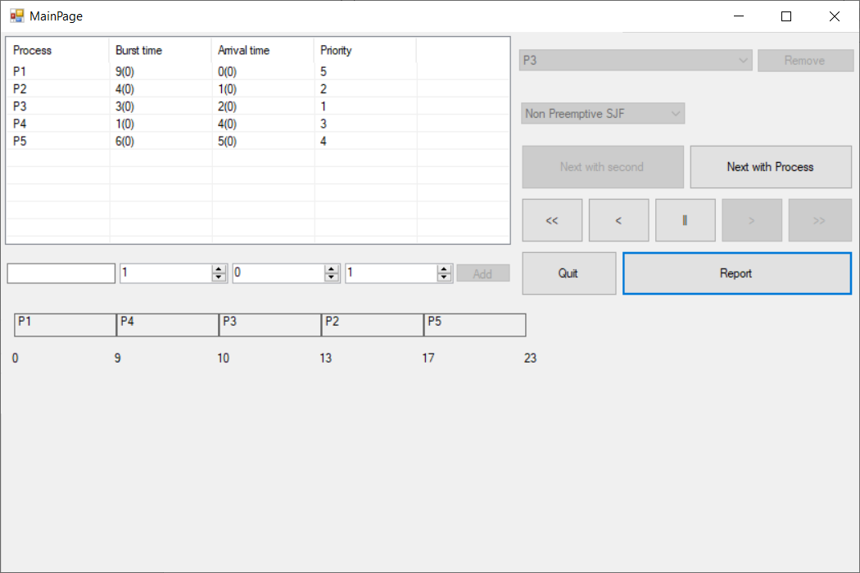

***Figure 7.*** *Programs run at Preemptive SJF with 5 process entered by user*

In Figure 7 shows the result after clicking the play button with the values entered by the user, the Gantt chart is displayed using Preemptive SJF algorithm. The rectangle button in the middle of the controller is used to stop the process.

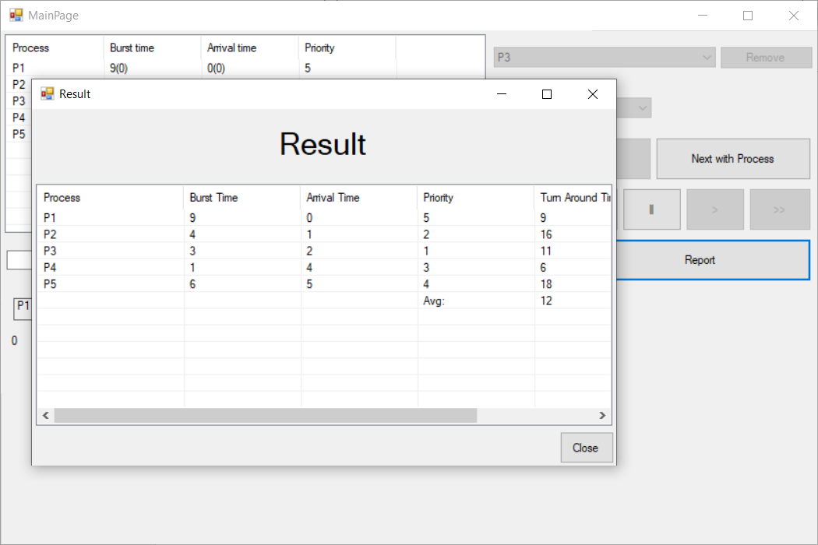

***Figure 8.*** *Report generated by the program to show the result of algorithm*

In Figure 8 shows the report that is generated after clicking the “Report” button and list out the summary points such as Turn Around Time, Average and Waiting time. The “Quit” button is used to quit the report page and return to the Main Menu Page.

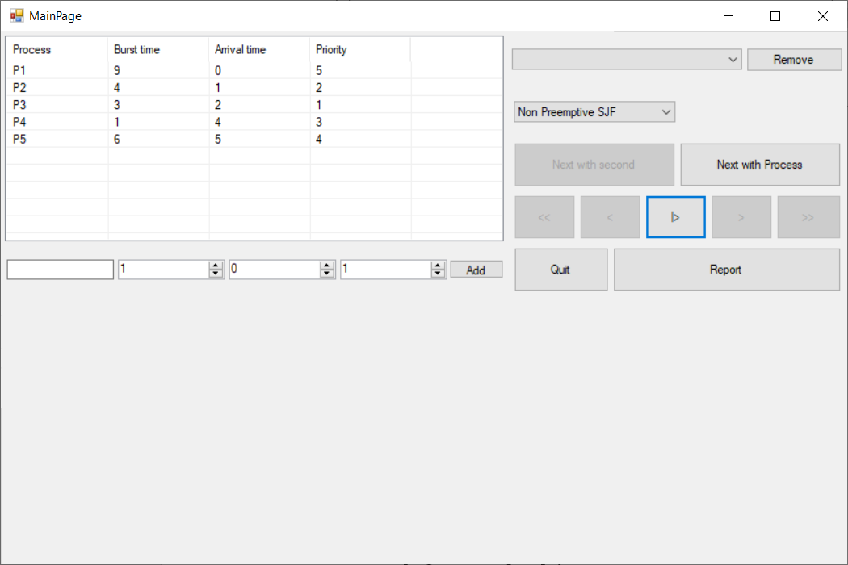

***Figure 9.*** *Programs run at Non Preemptive SJF with assignment values*

In Figure 9 shows the result that is generated by using the assignment default value running at Non preemptive SJF algorithm. When the user starts the program with no value inserted, the program would prompt you the default value.